Mary bethune school

Special Education PreK Supply List

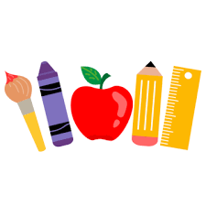

1 back-pack or book-bag (large enough for a pocket folder and lunchbox if sending your child to school with breakfast/lunch)

1 box of Ziplock sandwich bags

1 box of Ziplock gallon bags

2 containers of disinfecting wipes

2 bottles hand soap

4 rolls paper towels

1 change of clothes labeled with child’s name (include: socks, pants, and shirt – may need to be updated throughout the year once clothes are used)

Pull-Ups/ Diapers and wipes (if your child needs them)

With Gratitude,

Ms. Alaqua and Ms. Woods (Room 119)

Ms. Robinson and Ms. Fuller (Room 120)